Encoded Archival Description

Agenda

9:00-9:15 Introductions, course objectives, ground rules

9:15-10:15 Lessons 1-4

10:15-10:30 Break

10:30-12:00 Lessons 5-6

12:00-1:00 Lunch

1:00-2:45 Review
Lessons 7-9

2:45-3:00 Break

3:00-4:45 Lessons 10-12

4:45-5:00 Review

EAD Workshop

Table of Contents

Lesson 1. The Big Picture 4
Lesson 2. What are EAD and XML 5
Lesson 3. How Does XML Work 6
Lesson 4. Learning the XML Editor 14
Lesson 5. EAD Documentation 17
Lesson 6. EAD Elements—Descriptive Identification <did> 20
Lesson 7. EAD Elements—Biographical Sketch, Scope and Content,
and Arrangement 26
Lesson 8. EAD Elements--Controlled Access 31
Lesson 9. EAD Elements—"Administrative" Information 33
Lesson 10. EAD Elements—Description of Subordinate Components 37
Lesson 11. EAD Elements—EAD Header 39
Lesson 12. Implementing EAD 41

Appendix A. Resources 42
Appendix B. Software 44

Introduction

Workshop Goals

Basic familiarity with XML
Review of EAD documentation
Knowledge of EAD elements and structure
Experience creating an EAD finding aid
Overview of standards and other issues related to EAD implementation

Ground Rules

Keep discussion informal—ask questions!
Don’t work ahead
Learn from each other

Email only during breaks
Silence cell phones
Please return on time from breaks and lunch

Lesson 1: The Big Picture

Steps for Implementing EAD

1. Create finding aid in EAD
- Select authoring software
- Encode data

2. Provide a discovery method
- Links from MARC records
- Searchable full-text database
- Google

3. Prepare files for delivery
- Create stylesheet
- Transform file for Web delivery

Lesson 2: What are EAD and XML

Descriptive standards identify the elements of archival description

DACS ISDF
APPM DCRM
ISAD (G) OHCM
ISAAR (CPF) RDA

Authority files and thesauri supply terms used as access points in those descriptions

LCNAF TGM
LCSAF (LCSH) TGN
AAT ULAN

EAD provides a mechanism for electronically identifying in finding aids these descriptive elements and their relationships so that computers can manipulate the data.

EAD utilizes the syntax of Extensible Markup Language (XML) to make this happen.

XML is a protocol for the electronic management of data (ISO 8879).

Relational databases manage data by storing it in tables.

Spreadsheets manage numerical data by storing it in cells.

XML manages data by embedding identifying codes in the data itself.

XML data is simply Unicode text and is therefore independent of software and operating systems.

Lesson 3: How Does XML Work

Key XML Concepts

- Classes of documents

- Types of information

- Documentation

Schemas
Tag Libraries

- Markup

- Presentation through transformation

3.1. Classes of Documents

- Information with an identifiable set of common data elements:

Highly structured data
Driver’s license
Publishing data
Credit card verification transactions

Textual data
Novels
Poetry
Legislative hearing transcripts

Mixed character
Memoranda
Finding aids
Catalog records

- A user community identifies and defines the elements and their relationships so the data can be created and manipulated electronically

3.2 Types of Information to Manipulate

- Presentational
Display
- Descriptive
Structural (document components)
Nominal
- Referential
Linking

3.2.1 Identifying Structural Elements Exercise

Date: July 7, 2012

To: Solveig DeSutter

From: Michael Fox
Kris Kiesling

Subject: Upcoming workshop

We are looking forward to the next workshop.

Nous serons très heureux.

3.2.2 Memorandum Data Model

memo
heading
reference
date
to
from
subject
body
paragraph

3.3. Documenting the Structure: Document Type Definitions (DTD), Schemas, and Tag Libraries

- Structure: Rules of the Road

Defines structural components of a class of documents
Defines relationships between data elements, such as
sequence of elements
frequency of elements (repeatable, optional, mandatory)

- Documentation: Electronic form as a computer file

There are three EAD flavors

ead.dtd XML DTD syntax
ead.rng Relax NG schema syntax
ead.xsd W3C Schema syntax

Used by XML editors, validators, and XSL transformation engines

- Documentation: Written form in a user-friendly tag library

This page intentionally left blank.
3.4. Markup: Applying XML

3.4.1 Embed tags (identifying codes) within the data

<memo>
<heading>
<ref href="cchslogo.gif"/>
<date label="Date:">July 7, 2012</date>
<to label="To:">Solveig DeSutter</to>
<from label="From:">Michael Fox</from>
<from>Kris Kiesling</from>
<subject label="Subject:">Upcoming workshop</subject>
</heading>
<body>
<p> We are looking forward to the next workshop.</p>
<p>Nous serons tr&#232;s heureux.<p>
</body>

</memo>

3.4.2 XML Syntax

3.4.2.1 Elements
- Have start tags and end tags

<p> We are looking forward to the next workshop.</p>

- Have formal names and tag names
formal name = Paragraph
tag name (generic identifier) = <p>

- May contain text
PCDATA (parsable character data)

- May be empty
start and end tags <ref></ref>
XML empty element syntax <ref/>
<ref href="cchslogo.gif"/>

- May contain other elements
parents (wrappers)
children (nesting)

3.4.2.2 Attributes
- Expand on the meaning and content of elements
<unitdate type="bulk">
- Provide display information
<unittitle label="Title:">
- Uniquely identify an element
<persname id="p23">
- Specify addresses for the targets of links
<ref target="series1"/>

3.4.2.3 Entities
A set of characters referenced as a unit
special characters (&, ©, ß)
non-text files (images, sound files)
external text files (boilerplate text)
3.5 Presentation Through Transformation (Stylesheets)

- EAD focuses on structural content, not presentation

- Create web and print presentations through transformation with stylesheets

- Stylesheets are separate computer files written in XML syntax

- Based on the Extensible Stylesheet Language (XSL) programming language

- Transform XML content to HTML for the web or to PDF or RTF for print

- Can supply default text and images at the time of transformation

- Specify how the data appear
Text format: font, size, color, weight
Text layout: tabs, indents, line spacing, line breaks, tables

Example 1

Harry Ransom Humanities Research Center

University of Texas at Austin

Joyce, James, 1882-1941

James Joyce Collection, 1899-1968

11 boxes (4.58 linear feet), 5 galley folders, 7 oversize flat files

Example 2

Repository:
Harry Ransom Humanities Research Center, University of Texas at Austin
Creator:
Joyce, James, 1882-1941
Title:
James Joyce Collection
Dates:
1899-1968
Quantity:
11 boxes (4.58 linear feet), 5 galley folders, 7 oversize flat files

Transformations

XML
Document

Stylesheet

XSLT
Processor

HTML
Document
Saxon
Xalan
MSXSL
Browsers
OS

EAD
XSLT

Lesson 4: Learning the XML Editor

Four Steps:

4.1 Open oXygen XML editor
4.2 Create XML File: Memo
4.3 Associate stylesheet with XML file
4.4 Transform XML file into HTML

4.1 Open oXygen XML editor

File> Open > Your File Directory > Memo Template.xml

4.2 Create an XML Document: Insert the data from the following page

To insert an element
- Place cursor between the start tag and end tag of the element
- Press the spacebar to insert a new line
- Type the left angle bracket: "<"
- Select the desired element from the pop-up window using the Up and Down Arrows and the Enter key or double click with the mouse

To insert an attribute
- Place cursor before the closing angle bracket of the start tag
- Press the spacebar
- Select the desired attribute from the pop-up window using the Up and Down Arrows and the Enter key or double click with the mouse
- Insert the value of the attribute between the quotation marks

To insert text
1. Place cursor between the start tag and end tag and type
<memo>
<heading>
<ref href="cchslogo.gif"/>
<date label="Date:">July 7, 2012</date>
<to label="To:">Solveig DeSutter</to>
<from label="From:"Michael Fox</from>
<from>Kris Kiesling</from>
<subject label="Subject:">Upcoming workshop</subject>
</heading>
<body>
<p> We are looking forward to the next workshop.</p>
<p>Nous serons tr&#232;s heureux.<p>
</body>

</memo>

4.3 Associate a stylesheet with the XML file

4.3.1 In the oXygen XML editor, this is done with a Transformation Scenario which

- associates a stylesheet with an XML document

- specifies the file name, directory location, and type of the source and output documents and type of transformation

You can import an existing scenario or create your own later.

4.3.2 Import existing scenarios

Options > Import global transformation scenarios

Go To: Your File Directory> scenarios.xml

4.3.3 Select a Transformation Scenario

- Document > Transformation > Configure Transformation Scenarios

- Or Ctrl + Shift + C

- Select scenario to be applied

- Click "Save and Exit" or "Transform now" (see below)

4.4. Transform XML file to HTML

- Click on "Transform now"

- For subsequent transformations, once a scenario has been associated with an XML document, you can

- Click icon in the menu bar—the red triangle in a blue ring

- Or Ctrl + Shift + T

Lesson 5: EAD Documentation

EAD Tag Library

available at http://www.loc.gov/ead/tglib/index.html

Tag Library Conventions
Attributes
EAD elements
--brief description of the element
--may contain/may occur within (parents/children)
--list of attributes and attribute values
--encoded examples
Crosswalks to ISAD(G) and MARC21

William Fonds Provenance
An Inventory of His Papers at the Cupcake Corners Historical Society

Collection Summary

Provenance, William Fonds, 1897-1956

Papers of William Fonds Provenance

1917-1955

1.2 cubic feet (3 boxes)

Mss2 A

Cupcake Corners Historical Society

Correspondence, diaries and writings of an archival theorist and author documenting his experiences in World War I, his literary endeavors, and his ideas on modern archival theory, especially regarding the centrality of the fonds.

Biography of William Provenance

Archivist and author William Fonds Provenance was born at Last Chance, Nevada, to Fred and Mary Jones Provenance on January 4, 1987. Little is known of his early life prior to serving in World War I as an ambulance driver. After graduating from Freen College in 1924 with a degree in cryptogamic biology, he first followed a career in commercial horticulture and later worked as an itinerant archivist. Provenance also had a lifelong interest in creative writing, producing both novels and poetry. He died at Frostbite Falls, Minnesota, March 15, 1956.

Scope and Contents of the Papers

The collection consists of diaries, correspondence, manuscripts, and miscellaneous materials documenting the literary and archival career of William Fonds Provenance.

The bulk of the collection consists of correspondence, principally with his mother, other archivists and writers. His diaries describe his experiences as an ambulance driver in France during World War I in vivid detail. Major correspondents represented in the collection include Ernest Hemingway, Ernst Posner, and Provenance’s long-time companion Ima Gusdorf.

Arrangement of the Papers
The papers are arranged into two series:

Correspondence, 1919-1955.
Diaries, 1917-1918.

Related Records

The papers of Ima Gusdorf are located in the Freen University archives.

Index Terms
This collection is indexed under the following headings in the catalog of the Cupcake Corners Historical Society. Researchers desiring materials about related topics, persons, or places should search the catalog using these headings.

Persons:
Gusdorf, Ima May
Hemingway, Ernest, 1899-1961
Posner, Ernst

Subjects:
Cataloging of archival materials
United States – History – World War, 1914-1918 – Personal narratives, American

Document Types:
Diaries
Novels

Restrictions on Access
Access to the correspondence between Provenance and Ernest Hemingway is restricted until 2025.

Acquisition Information
Acquired as a gift from Ima Gusdorf, December 17, 1952.

Processing Information
Collection processed and cataloged by B.W. Moos, January, 1962.

Lesson 6: EAD Elements—Descriptive Identification

Multilevel Description
Finding aids typically consist of several descriptions of the entire collection at increasing levels of detail:

- General description of entire body of materials (biographical sketch, scope and contents, administrative information)
- Description of individual series or other groupings (series or subseries descriptions)
- Description of files or items (container or folder list)

EAD High Level Model

<ead>
<eadheader> describes the electronic finding aid
<frontmatter> for formal publication of finding aid
<archdesc> the description of the archival unit
</ead>

Description of the Archival Unit <archdesc>

<archdesc>
<did> descriptive identification of unit
<bioghist> biography/organizational history
<scopecontent> scope and contents
<arrangement> physical/logical ordering
<controlaccess> controlled access points
<dsc> description of subordinate components

Descriptive Identification of the Unit <did>

<archdesc>
<did> descriptive identification of unit
<repository> <physloc>
<origination> <container>
<unittitle> <note>
<unitdate> <dao> and <daogrp>
<physdesc> <head>
<unitid>
<abstract>
<langmaterial>
<materialspec>
Repository—name of the holding institution

<repository>
<corpname>Freen University
<subarea>Center for the Study of Archivy
</subarea>
</corpname>
</repository>

Origination—creator or collector of material being described

<origination>Provenance, William Fonds, 1897-1938</origination>

<origination>
<persname>Provenance, William Fonds, 1897-1938</persname>
</origination>

Unit Title—title of the material being described

<unittitle>William Fonds Provenance Papers</unittitle>

<unittitle>Correspondence, 1914-1925</unittitle>

Unit Date—date(s) of the material being described

<unitdate>
Attributes--
type (inclusive or bulk)
normal—a standard form of the date to facilitate searching
(YYYYMMDD format)

<unitdate type=“inclusive” normal=“1917/1937”>1917-1937 </unitdate>

Physical Description

<physdesc>100 boxes, 50 linear feet</physdesc>

<physdesc>
<extent>10</extent>
<genreform>photographs</genreform>
</physdesc>

Identifier of the Unit

<unitid> a unique identifier for the collection, series, file, item, etc.

Attributes—
countrycode--ISO code for the country of the repository that is the custodian of the materials
repositorycode--ISO code for the repository

<unitid countrycode=“US” repositorycode= “TxU-Hu”>Mss 813</unitid>

<unitid type=“accession number”>M-4392</unitid>

Abstract and Note
<abstract>
a short statement about the contents and creator of the materials to assist users in selecting relevant collections

<note>
explanatory text, requires a child <p>, is also available outside <did>

<abstract>The papers of William Fonds Provenance, author of the landmark <title render=“italic”>Quarks: The Tao of Archives, </title>document his college years, participation in World War I and European exile, as well as his brief, but illustrious archival career. The papers also contain diaries and correspondence describing his relationship with his mother and his unsuccessful literary career.</abstract>

<note><p>To request materials, please put the collection name, and the box and folder numbers on your call slip.</p></note>

Language of the Material

<langmaterial>
Correspondence in <language>French, </language><language>German, </language> and <language>English.</language>
</langmaterial>

Container

TYPE attribute

<container type=“Box”>1</container>
<container type=“Folder”>5</container>

<container type=“Box-Folder”>2.7</container>

<container type=“Reel”>7-10</container

Physical Location

<physloc type=“repository”>5C:SW:6.5</physloc>

<physloc>Collection is in off-site storage, requires 24-hour notice for paging.</physloc>

Descriptive Identification of the Unit

<archdesc>
<did>
<repository> <physloc>
<origination> <container>
<unittitle> <note>
<unitdate> <dao> and <daogrp>
<physdesc> <head>
<unitid>
<abstract>
<langmaterial>
<materialspec>

<did> child attributes

encodinganalog
<unittitle encodinganalog=“245”>William Fonds Provenance Papers</unittitle>

label
<unittitle label=“Title:”>
William Fonds Provenance Papers
</unittitle>

Collection Summary

Provenance, William Fonds, 1897-1956

Papers of William Fonds Provenance

1917-1955

1.2 cubic feet (3 boxes)

Mss2 A

Cupcake Corners Historical Society

Correspondence, diaries and writings of an archival theorist and author documenting his experiences in World War I, his literary endeavors, and his ideas on modern archival theory, especially regarding the centrality of the fonds.

Lesson 7: Biographical Sketch, Scope and Content, and Arrangement

Biography or History <bioghist>

<archdesc>
<bioghist>
<head>
<p>
<chronlist> Chronology
<chronitem>
<date>
<event> or <eventgrp>
<dao>
</bioghist>

Example—narrative <bioghist>

Biography of William Provenance

Archivist and author William Fonds Provenance was born at Last Chance, Nevada, to Fred and Mary Jones Provenance on January 4, 1987. Little is known of his early life prior to serving in World War I as an ambulance driver. After graduating from Freen College in 1924 with a degree in cryptogamic biology, he first followed a career in commercial horticulture and later worked as an itinerant archivist. Provenance also had a lifelong interest in creative writing, producing both novels and poetry. He died at Frostbite Falls, Minnesota, March 15, 1956.

Example: Encoded narrative <bioghist>

<bioghist>
<head >Biography of William Provenance</head>
<p>Archivist and author William Fonds Provenance was born at Last Chance, Nevada, to Fred and Mary Jones Provenance on January 4, 1897. Little is know of his early life prior to serving in World War I as an ambulance driver. After graduating from Freen College in 1924 with a degree in cryptogamic biology, he first followed a career in commercial horticulture and later worked as an itinerant archivist. Provenance also had a lifelong interest in creative writing, producing both novels and poetry. He died at Frostbite Falls, Minnesota, on March 15, 1956.</p>
</bioghist>

Example: Chronology <bioghist>

Biography of Arvonne Skelton Fraser

Date Event
1925 Sept. 1 Born in Lamberton, Minnesota, daughter of Orland Delbert and Phyllis Dufrene Skelton
1946-1949 First marriage to Perry Morgan.
1948 B.A., University of Minnesota.
Receptionist, Humphrey for Senator Campaign.
1948-1951 Secretary, Democratic-Farmer-Labor Party State Chairman.

Example: Encoded chronology <bioghist>

<bioghist>
<head>Biography of Arvonne Skelton Fraser</head>
<chronlist>
<listhead>
<head01>Date</head01>
<head02>Event</head02>
</listhead>
<chronitem>
<date>1925 Sept. 1</date>
<event>Born in Lamberton, Minnesota, daughter of Orland Delbert and Phyllis Dufrene Skelton.</event>
</chronitem>
<chronitem>
<date>1946-1949</date>
<event>First marriage to Perry Morgan.</event>
</chronitem>
<chronitem>
<date>1948</date>
<eventgrp>
<event>B.A., University of Minnesota.</event>
<event>Receptionist, Humphrey for Senator Campaign.</event>
</eventgrp>
</chronitem>
<chronitem>
<date>1948-1951</event>
<event>Secretary, Democratic-Farmer-Labor Party State Chairman.</event>
</chronitem>
</chronlist>
</bioghist>
Scope and Content <scopecontent>

<archdesc>
<scopecontent>
<head>
<p>
<arrangement>
<scopecontent>
</scopecontent>

Example—Scope and Content

Scope and Contents of the Papers

The collection consists of diaries, correspondence, manuscripts, and miscellaneous materials documenting the literary and archival career of William Fonds Provenance.

The bulk of the collection consists of correspondence, principally with his mother, other archivists and writers. His diaries describe his experiences as an ambulance driver in France during World War I in vivid detail. Major correspondents represented in the collection include Ernest Hemingway, Ernst Posner, and Provenance’s long-time companion Ima Gusdorf.

Example—Encoded <scopecontent>

<scopecontent>
<head >Scope and Contents of the Papers</head>
<p>The collection consists of diaries, correspondence, manuscripts, and miscellaneous materials documenting the literary and archival career of William Fonds Provenance.</p>

<p>The bulk of the collection consists of correspondence, principally with his mother, other archivists and writers. His diaries describe his experiences as an ambulance driver in France during World Was I in vivid detail. Major correspondents represented in the collection include Ernest Hemingway, Ernst Posner, and Provenance's long-time companion Ima Gusdorf. </p>
</scopecontent>
Arrangement <arrangement>

<archdesc>
<arrangement>
<head>
<p>
<list>
<arrangement>
</arrangement>

Example—arrangement

Arrangement of the Papers

The papers are arranged into two series:
Correspondence, 1919-1955.
Diaries, 1917-1918.

Example—encoded <arrangement>

<arrangement>
<head>Arrangement of the Papers</head>
<p>The papers are arranged into two series:</p>
<list>
<item>
<ref target="series1">Correspondence, 1919-1955</ref>
</item>
<item>
<ref target="series2">Diaries, 1917-1918</ref>
</item>
</list>
</arrangement>

Biography of William Provenance

Archivist and author William Fonds Provenance was born at Last Chance, Nevada, to Fred and Mary Jones Provenance on January 4, 1987. Little is known of his early life prior to serving in World War I as an ambulance driver. After graduating from Freen College in 1924 with a degree in cryptogamic biology, he first followed a career in commercial horticulture and later worked as an itinerant archivist. Provenance also had a lifelong interest in creative writing, producing both novels and poetry. He died at Frostbite Falls, Minnesota, March 15, 1956.

Scope and Contents of the Papers

The collection consists of diaries, correspondence, manuscripts, and miscellaneous materials documenting the literary and archival career of William Fonds Provenance.

The bulk of the collection consists of correspondence, principally with his mother, other archivists and writers. His diaries describe his experiences as an ambulance driver in France during World War I in vivid detail. Major correspondents represented in the collection include Ernest Hemingway, Ernst Posner, and Provenance’s long-time companion Ima Gusdorf.

Arrangement of the Papers
The papers are arranged into two series:

Correspondence, 1919-1955.
Diaries, 1917-1918.

Lesson 8: Controlled Access

As librarians do in catalog records, archivists provide controlled vocabulary access points to help people find relevant materials.

Index Terms
This collection is indexed under the following headings in the catalog of the Cupcake Corners Historical Society. Researchers desiring materials about related topics, persons, or places should search the catalog using these headings.

Persons:
Gusdorf, Ima May
Hemingway, Ernest, 1899-1961
Posner, Ernst

Subjects:
Cataloging of archival materials
United States – History – World War, 1914-1918 – Personal narratives, American

Document Types:
Diaries
Novels

Example—Encoded <controlaccess>

<controlaccess>
<head>Index Terms</head>
<p>This collection is indexed under the following headings in the catalog of the Cupcake Corners Historical Society. Researchers desiring materials about related topics, persons, or places should search the catalog using these headings.</p>
<persname encodinganalog="700">Gusdorf, Ima May</persname>
<persname encodinganalog="700">Hemingway, Ernest, 1899-1961</persname> <persname encodinganalog="700">Posner, Ernst</persname>
<subject>Cataloging of archival materials</subject>
<subject>United States --History -- World War, 1914-1918 – Personal narratives, American</subject>
<genreform>Novels</genreform>
<genreform>Diaries</genreform>
</controlaccess>

Index Terms

This collection is indexed under the following headings in the catalog of the Cupcake Corners Historical Society. Researchers desiring materials about related topics, persons, or places should search the catalog using these headings.

Persons:

Gusdorf, Ima May
Hemingway, Ernest, 1899-1961
Posner, Ernst

Subjects:

Cataloging of archival materials
United States – History – World War, 1914-1918 – Personal narratives, American

Document Types:

Diaries
Novels

Lesson 9: "Administrative" Information

Restrictions on Access <accessrestrict>

<accessrestrict>
<head>Restrictions on Access</head>
<p>Access to the correspondence between Provenance and Ernest Hemingway is restricted until 2025.</p>
</accessrestrict>

Restrictions on Use <userestrict>

<userestrict>
<head>Copyright Notice:</head>
<p>Permission for publication is given on behalf of the Cupcake Corners Historical Society as the owner of the collection and is not intended to include or imply permission of the copyright holder, which must also be obtained by the researcher.</p>
</userestrict>

Acquisition Information <acqinfo>

<acqinfo encodinganalog="541">
<head>Acquisition Information</head>
<p>Acquired as a gift from Ima Gusdorf, December 17, 1952.</p>
</acqinfo>

Processing Information <processinfo>

<processinfo encodinganalog="583">
<head>Processing Information</head>
<p>Collection processed and cataloged by B.W. Moos, January 1962.</p>
</processinfo>

Related Material <relatedmaterial>

Material that did not come from the same creator.

<relatedmaterial>
<head>Related Records</head>
<p>The papers of Ima Gusdorf are located in the Freen University archives.</p> </relatedmaterial>

Separated Material <separatedmaterial>

Material that came from the same creator.

<separatedmaterial>
<p>Provenance's letters to Minnesota governor Orville Freeman from 1955 are at the Minnesota Historical Society.</p>
</separatedmaterial>

Appraisal <appriasal>

<appraisal>
<p>Case files were sampled before transfer.</p>
</appraisal>

Custodial History <custodhist>

<custodhist>
<p>Following his death, Provenance’s papers were bequeathed to his brother, Harry, who attempted several times, unsuccessfully, to sell them to a private collector. Upon Harry’s death, the papers became the property of Provenance’s literary executrix and longtime companion, Ima Gusdorf, who donated them to the Freen University Center for the Study of the Giants of Archivy.</p>
</custodhist>

Alternate Form Available <altformavail>

<altformavail>
<p>Diary available on microfilm.</p>
</altformavail>

Preferred Citation <prefercite>

<prefercite>
<p>Please cite as: John Berryman Papers, Upper Midwest Literary Archives, University of Minnesota Libraries</p>
</prefercite>

Related Records

The papers of Ima Gusdorf are located in the Freen University archives.

Restrictions on Access

Access to the correspondence between Provenance and Ernest Hemingway is restricted until 2025.

Acquisition Information

Acquired as a gift from Ima Gusdorf, December 17, 1952.

Processing Information

Collection processed and cataloged by B.W. Moos, January, 1962.

Lesson 10: Description of Subordinate Components

Detailed Description of the Collection

The following section contains a detailed listing of the materials in the collection.

Correspondence, 1919-1955. 5 folders

Incoming letters and copies of outgoing correspondence with family, business associates, and prominent archivists and writers. Letters are arranged alphabetically by the writer’s or recipient’s name.

Box Folder
1 1 A-F
2 Gusdorf, Ida, 1942-1955
Box Folder
2 1 H-P
2 Schellenberg, Theodore
Box Folder
3 1 T-Z

Diaries, 1917-1918. 32 v. in 4 folders

Daily accounts of Provenance’s experiences during his military service in France during World War I, primarily documenting the daily activities of camp life, weather, military battles, and operations of the army medical service. Also contains detailed and graphic accounts of his work as an ambulance driver.

Box Folder
3 2-3 1917
2 January-March
3 April-September
4-5 1918
4 January
5 February-June

Detailed Description of the Collection

The following section contains a detailed listing of the materials in the collection.

Correspondence 1919-1955 5 folders

Incoming letters and copies of outgoing correspondence with family, business associates, and prominent archivists and writers. Letters are arranged alphabetically by the writer’s or recipient’s name.

Box Folder
1 1 A-F
2 Gusdorf, Ida, 1942-1955
Box Folder
2 1 H-P
2 Schellenberg, Theodore
Box Folder
3 1 T-Z

Diaries 1917-1918 32 v. in 4 folders

Daily accounts of Provenance’s experiences during his military service in France during World War I, primarily documenting the daily activities of camp life, weather, military battles, and operations of the army medical service. Also contains detailed and graphic accounts of his work as an ambulance driver.

Box Folder
3 2-3 1917
2 January-March
3 April-September
4-5 1918
4 January
5 February-June
Lesson 11: EAD Header

High Level Model
<ead>
<eadheader> describes the electronic finding aid
<frontmatter> for formal publication of finding aid
<archdesc> the description of the archival unit
</ead>

EAD Header Attributes
audience=“external” or “internal”
encodinganalog=“MARC”
langencoding=“iso639-2b”
countryencoding=“iso3166-1”
dateencoding=“iso8601”
repositoryencoding=“iso15511”
scriptencoding=“iso15924”

EAD ID—unique identifier for the finding aid <eadid>
Attributes—
countrycode
mainagencycode
url or urn

<eadid>urn:taro:utexas.hrc.00001</eadid>

<eadid countrycode=“US” mainagencycode=“Txu-Hu”>hrc.00001</eadid>

File Description <filedesc>
<filedesc>
<titlestmt>
<titleproper> <subtitle> <author>
<publicationstmt>
<publisher> <date>
</filedesc>

Profile Description <profiledesc>
<profiledesc>
<creation> of the electronic finding aid
<date>
PCData
<langusage> language of the finding aid
<language>
<descrules> description rules used
</profiledesc>

Revision Description—version control
<revisiondesc>
<change>
<date> <item>
</revisiondesc>

Example—encoded <eadheader>

<eadheader>
<eadid countrycode="US" mainagencycode="mncchi">2468</eadid>
<filedesc>
<titlestmt>
<titleproper>William Fonds Provenance</titleproper>
<subtitle>An Inventory of His Papers at the Cupcake Corners Historical Society</subtitle>
<author>Inventory prepared by B. W. Moos</author>
</titlestmt>
<publicationstmt>
<publisher>Cupcake Corners Historical Society</publisher>
<date>August 6, 2012</date>
</publicationstmt>
</filedesc>
<profiledesc>
<creation>Finding aid encoded by Kris and Michael on
<date>August 6, 2012</date>
</creation>
<langusage>Finding aid written in <language>English</language>
</langusage>
<descrules>Finding aid prepared according to DACS</descrules>
</profiledesc>
</eadheader>

Lesson 12: Implementing EAD

Which Elements Are Required?

<ead>
<eadheader>
<eadid>
<filedesc>
<titlestmt>
<titleproper>
<archdesc> and LEVEL attribute
<did>

Programmatic Issues

Institutional mission and goals
Resources
Staffing, training, and workflow
Converting existing finding aids
- Rekey text
- Cut and paste into an editor
- Outsource markup
IT department?
Evaluate and standardize current practices
EAD only?
MARC21? (if so, you can use MARCEdit to convert)
Cooperative ventures/consortia

Appendix A: Resources

Official EAD Web site with online Tag Library
http://www.loc.gov/ead/

SAA EAD Roundtable Help Pages—
http://www.archivists.org/saagroups/ead/
plus
EAD Cookbook
- templates in <oXygen/>, NoteTab, and XMetaL
- stylesheets
- encoding protocol

EAD listserv
ead@loc.gov
listserv@loc.gov (sub ead your name)

Encoding Protocols
RLG Best Practice Guidelines for EAD
http://www.oclc.org/programs/ourwork/past/ead/bpg.pdf
Library of Congress Best Practices
http://www.loc.gov/ead/practices/lcp2002.html

Michael Fox
foxmjc@gmail.com

Kris Kiesling
305 Andersen Library
University of Minnesota
222 21st Avenue S.
Minneapolis, MN 55455
(612) 626-5776
kiesling@umn.edu

Resources: Creating Stylesheets

What the Archivist Needs To Do

- Review current finding aids
- Data content
- Order of information
- Layout of text

- Determine new presentation
- Table of contents
- Text display
- Order of data

- Create encoding that supports the desired output
- Heads and labels
- Hyperlinks

- Apply encoding consistently
- Encoding protocol
- Templates

What Stylesheet Authors and Editors Need To Know

- EAD structure, especially hierarchies, as locally applied.

- XML tree structures in EAD
- Context of elements

2. Basic HTML, sufficient to produce desired output

3. XSLT programming language

Appendix B. Software

<oXygen/>

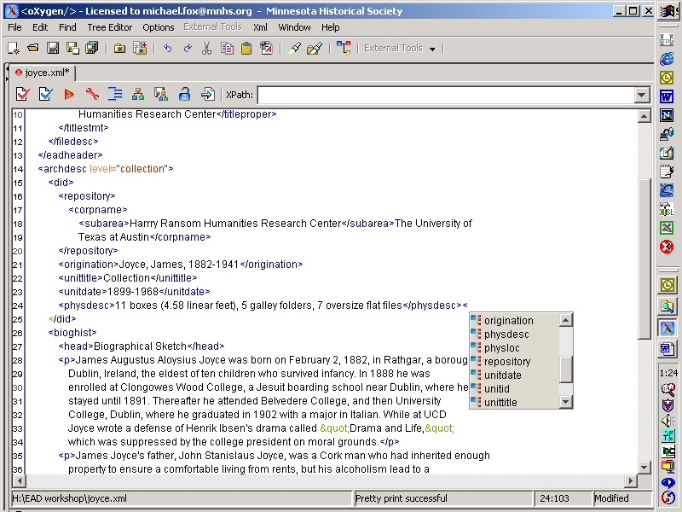

Produces: XML instances

Platforms: Windows, Solaris, Linux, Mac OS X

Features: A cross-platform XML editor that is also capable of creating XSLT stylesheets. Features context sensitive editing using either DTDs or W3C schemas. XSLT and FO transformations facilitated.

Price: $349 ($64 academic and non-profit, including one year of support). Discounts for more than 5 copies.

Available From:
Available only via download from the web at:
www.oxygenxml.com

XMetaL Author

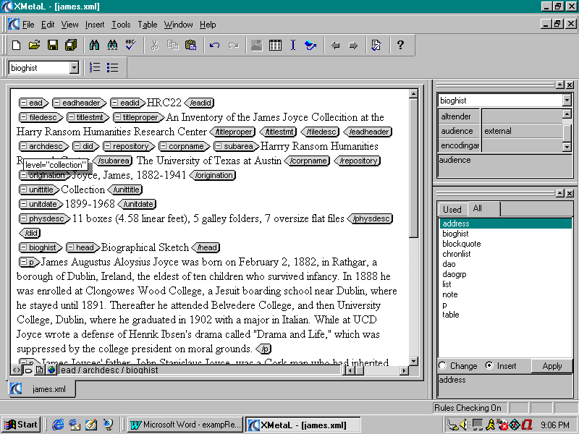

Produces: SGML or XML instances

Platforms: Windows 95, 98, NT, 2000, XP

Features: templates, macros, spell checker, thesaurus, stylesheet generator (CSS), generates xml from relational database tables. Uses ascii or binary form of the DTD. (File “ead.rlx” available at http://www.archivists.org/saagroups/ead/ead2002cookbookhelp.html)

Price: US $1195, $262 for one year of maintenance

Available from:
Justsystems
866-793-1542
http://na.justsystems.com/content-xmetal

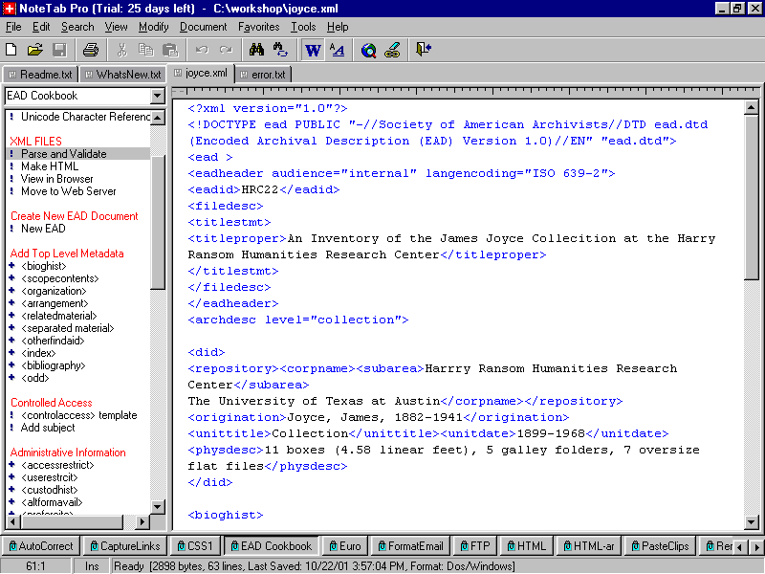
NoteTab

Produces: XML instances

Platforms: Windows

Features: Sophisticated Windows text editor. Customizations of NoteTab that support the encoding protocol found in the EAD Cookbook are available from the EAD Help Pages web site. These include templates and macros for faster data entry. The software also has links to external parsers and XSLT transformation software. Available only via download from the web.

Price: NoteTab Light--free; NoteTab Standard--$19.95; NoteTab Pro--$29.95

Available From:
Fookes Software
Av Eugene-Pittard 22 Ter
CH- 1206 Geneva
Switzerland
http://www.notetab.com/

xmlspy

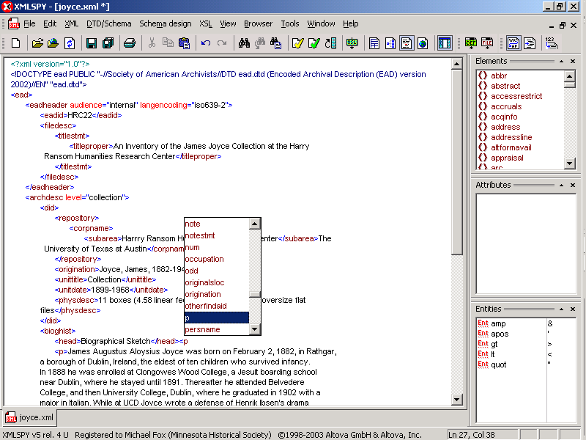

Produces: XML instances

Platforms: Windows 98, ME, 2000, NT, XP

Features: A cross-platform XML editor that is also capable of creating XSLT stylesheets. Features context sensitive editing using either DTDs or W3C schemas. XSLT and FO transformations facilitated.

Price: $189 Standard edition. Discounts for multiple copies. Annual support contract additional ($47.25/year).

Available From:
Available only via download from the web at:
www.altova.com

